Technical Assessment
The Scenario: "Deceptive Review Detection in the Wild"

Contents
NLP Pipeline Design 3
1. Introduction 3
2. System Overview 3
3. Key Pipeline Components 4
Zero-Label Psychological Manipulation Detection 4
Approach 1: Rule-Based Detection with Semantic Validation 5
Approach 2: Unsupervised Pattern Discovery 5
System Design & Edge Cases 6
Q1: Latency Optimization 6
Q2: Adversarial Robustness 6
Q3: Confidence Calibration 6
Q4: Cold Start for New Categories 7
Q5: Ethical Consideration – Review Updates 7
Conclusion 7

NLP Pipeline Design

1. Introduction
Online reviews strongly influence purchasing decisions, which makes them an attractive target for manipulation. Modern deceptive reviews are often written by humans who intentionally sound balanced, emotional, and authentic. Because of this, traditional spam filters that rely on surface-level patterns are no longer sufficient.
The goal of this system is to detect such deceptive reviews by analyzing semantic consistency, psychological intent, and writing behavior. Instead of asking “Does this review look fake?”, the system asks, “Does this review make sense as a whole?”

2. System Overview
The system is designed as a modular NLP pipeline, where each stage focuses on a different signal:
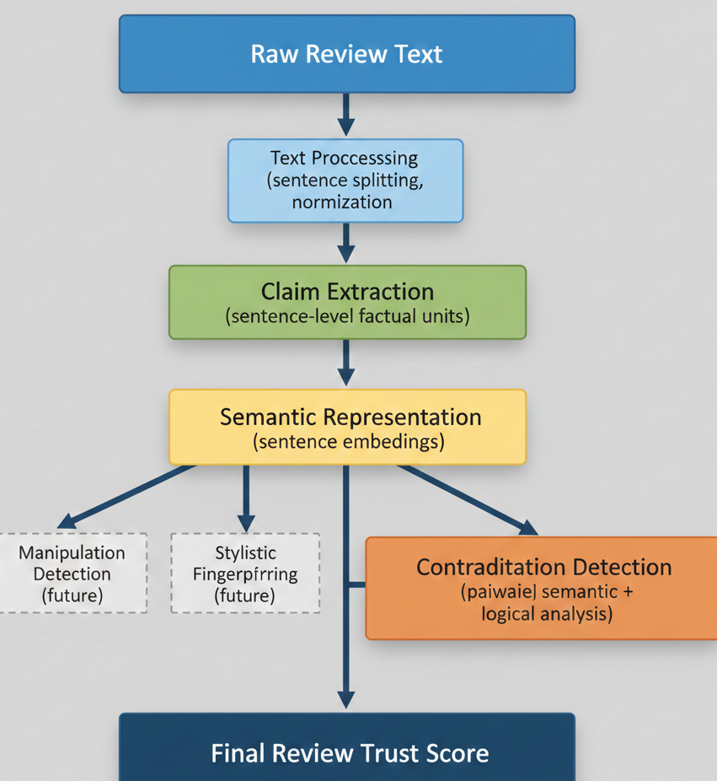
This structure makes the system easy to maintain, scale, and improve over time

3. Key Pipeline Components

Text Preprocessing
The review text is normalized and split into individual sentences. Working at the sentence level allows the system to compare claims that may appear far apart in the review.

Claim Extraction
Each sentence is treated as a potential claim. These claims represent opinions, experiences, or factual statements made by the reviewer.
For example:
- “The battery lasts forever.”
- “I have to charge it twice a day.”
Individually, these statements appear reasonable. Together, they raise a clear inconsistency.

Semantic Representation
Each claim is converted into a semantic vector using Sentence-BERT. This allows the system to recognize meaning even when the wording differs.
Sentence-BERT was chosen because it:
- Handles paraphrasing well
- Is computationally efficient
- Does not require task-specific training data

Contradiction Detection
Claims are compared pairwise. If two claims discuss the same topic but express opposing meanings or sentiments, the system flags a contradiction and assigns a confidence score.
The output includes:
- A contradiction flag
- A confidence score
- The contradicting sentence pairs
This makes the result transparent and easy to interpret.

Zero-Label Psychological Manipulation Detection
A major constraint in this project is the absence of labeled data for manipulation detection. Since waiting for annotations is not practical, the solution must work without supervision while remaining reliable.

Approach 1: Rule-Based Detection with Semantic Validation
This approach starts from the observation that manipulation often follows recognizable psychological patterns. Common tactics include urgency (“buy now”), scarcity (“only a few left”), and social pressure (“you should get this too”).
The system first detects these patterns using lightweight linguistic rules. To avoid rigid keyword matching, semantic embeddings are used to validate intent. This allows the system to detect paraphrased manipulation such as “I bought three just in case,” even when exact keywords are missing.
Pros
- No labeled data required
- Easy to explain and debug
- Quick to deploy
Cons
- Limited coverage for novel manipulation styles
- Requires occasional rule refinement
Expected Performance
High precision (around 70–80%) with moderate recall in early stages.
Validation
- Manual review of flagged samples
- A/B testing against existing moderation rules

Approach 2: Unsupervised Pattern Discovery
In this approach, reviews are embedded and grouped using unsupervised clustering. Clusters that contain a high concentration of emotionally charged or urgency-driven language are flagged as suspicious.
Over time, these clusters act as pseudo-labeled data, allowing the system to adapt to new manipulation strategies without human annotation.
Pros
- Discovers new manipulation patterns automatically
- Improves with more data
- No annotation cost
Cons
- Less interpretable initially
- Requires careful threshold tuning
Expected Performance
Moderate initial precision (~65%) with recall improving as clusters stabilize.
Validation
- Human sampling of cluster outputs
- Monitoring cluster consistency over time

System Design & Edge Cases

Q1: Latency Optimization
To reduce latency from 200ms to under 50ms:
- Cache sentence embeddings for repeated content
- Use smaller or distilled embedding models
- Batch sentence encoding and parallelize comparisons

Q2: Adversarial Robustness
Attack: Paraphrased contradictions
Defense: Semantic embeddings detect meaning-level inconsistencies
Attack: Contradictions spread across long reviews
Defense: Topic-based segmentation before comparison

Q3: Confidence Calibration
If confidence scores are overconfident:
- Apply temperature scaling
- Use isotonic regression
- Continuously monitor calibration curves

Q4: Cold Start for New Categories
With limited labeled data:
- Fine-tune embeddings on the new domain
- Transfer knowledge from related categories
- Combine rules with lightweight supervision

Q5: Ethical Consideration – Review Updates
Some users legitimately update reviews over time. To avoid penalizing honest behavior:
- Detect update markers such as “Update:”
- Down-weight contradictions across long time gaps
- Route ambiguous cases to human review

Conclusion
This system focuses on understanding meaning, intent, and consistency rather than relying on shallow patterns. By combining semantic contradiction detection, manipulation analysis, and stylistic signals, it provides a practical and scalable solution for identifying deceptive reviews in real-world environments.

